Zoom会议使用指南

How to Use Zoom
加入会议详见：
Please check how to join a meeting here:
https://support.zoom.us/hc/zh-cn/articles/201362193.
https://support.zoom.us/hc/en-us/articles/201362193.

更多详见：
For more information:
https://support.zoom.us/hc/en-us/categories/200101697-Getting-Started.

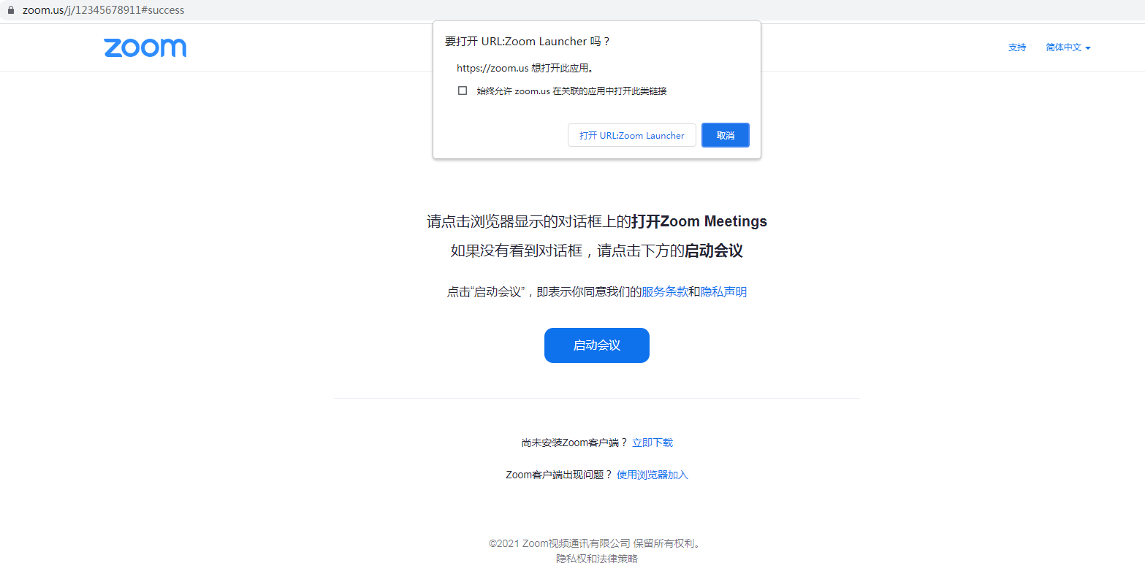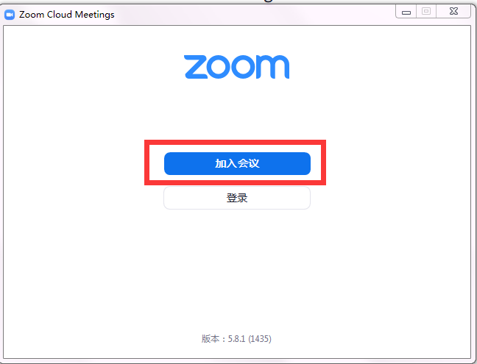

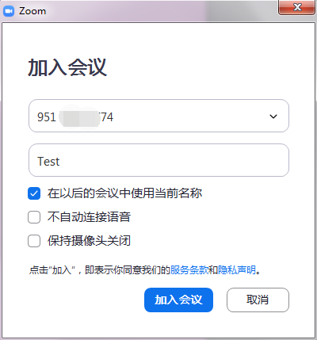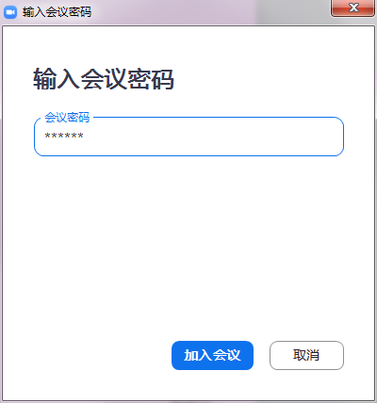
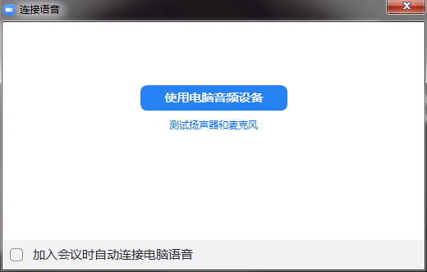
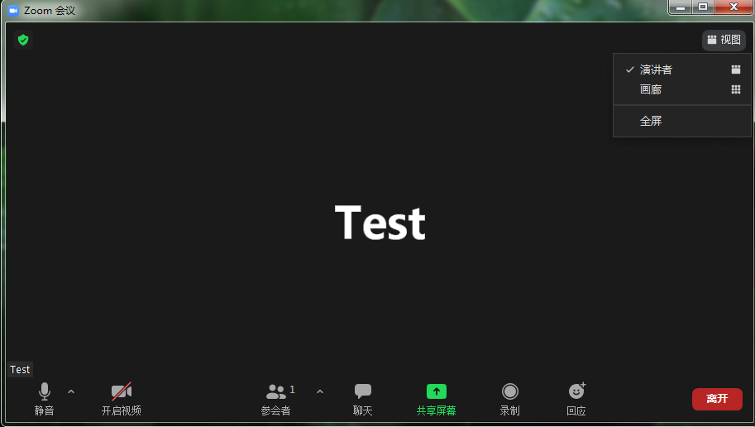
备用软件为腾讯会议，下载安装和使用指南详见：https://meeting.tencent.com/。
Tencent VooV Meeting will be the backup application. Please also down, install and check how to use here: https://voovmeeting.com/.

注册会议

Registration
打开链接或扫描二维码在线报名（无会议注册费）：
Open the link or scan the QR code to register online (no registration fee): https://www.wjx.cn/vj/hd4OJdg.aspx
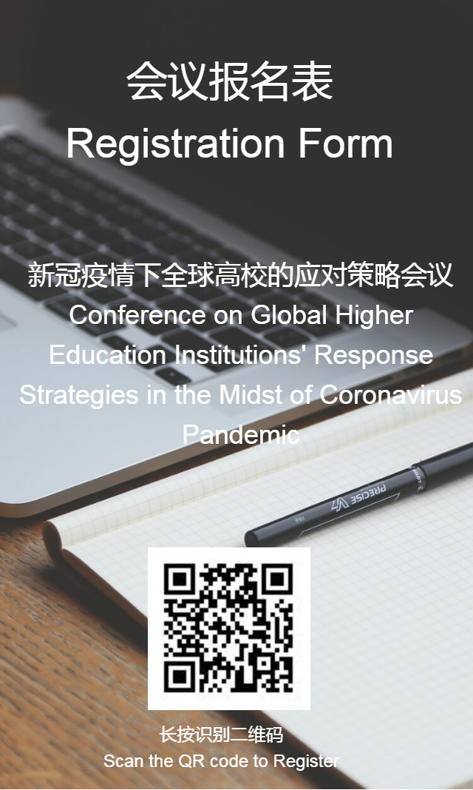

联系方式

Contact us
唐明凤教授
Prof. Mingfeng Tang
工商管理学院院长助理（国际事务）
Assistant Dean in charge of International Affairs Office, School of Business Administration
电话Tel: +86-(0)28-87359009
邮箱Email: tang@swufe.edu.cn

周瑞艳女士
Ms. Catherine Zhou
工商管理学院国际事务办公室协调员
Programme Coordinator, International Affairs Office, School of Business Administration
电话Tel: +86-(0)28-87092286
邮箱Email: zry@swufe.edu.cn

谢真真女士
Ms. Zhenzhen Xie
国际交流与合作处（港、澳、台事务办公室）
Office of International Exchange and Cooperation (Office of Hong Kong, Macao and Taiwan affairs)
电话Tel: +86-(0)28-87092553
邮箱Email: zhenzhenx@swufe.edu.cn

